**SELF CONTROLLED LOCOMOTIVE FOR THE FASTEST NEW AGE TECHNOLOGY**

**1. INTRODUCTION**

We know that the railway network of India is the biggest in south Asia and perhaps the most complicated in all over the world. There are so many different types of trains local, fast, super fast, passenger, goods…. etc. and there so many multiple routes. Although the time table is perfect it is not at all possible to maintain it. And that’s why the train accidents are becoming more and more usual. So why not we add a kind of intelligence to the train engines itself so that it tries to avoid accidents.

The idea is whenever any engine observes a red signal on its track it will start decreasing its speed gradually and stops automatically at some distance from the signal pole. After then when it gets green signal the driver can manually start the train and go on. In the mean time when train has not stopped yet and a red signal becomes green then it crosses the signal pole with low speed and then driver can slowly increase the speed.

So, now before the driver observes the red signal the engine itself observes it and automatically starts decreasing speed and then stops. The driver can feel relax in driving because he doesn’t have to take care about red signal. Even if he forgets to take any action on red signal then also we can avoid accidents by the implementation of this idea.

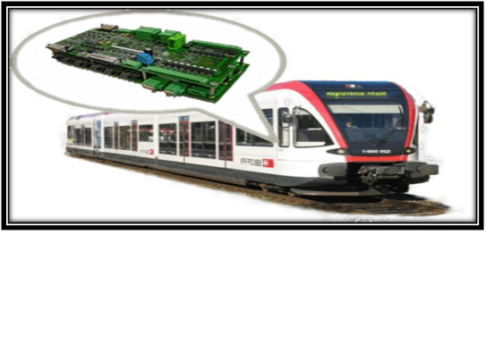

**Fig1: Self Controlled Locomotive**

In a rapidly flourishing world, automation has become the key factor in our daily life. As we have reached in 21st century and now a days as technology is progressing and lot of modernization in the form of automation can be seen. Inspired from this fact we are developing a new idea of making an automatic Intelligent Train Engine. No fruitful steps have been taken so far in this area. Our project deals with automatic railway engine which automatically checks the status of lights and perform the desired operations. This idea makes our train works automatically even in the absence of driver. The circuit developed in this work provides safety to the users by employing lights at poles which transmits a signal, which is then further received at receiver i.e. at our train engine. The engine will receive different signals from different lights and the train will run accordingly i.e. at Red Signal train will stop, at green signal train will run at full speed and at yellow signal, the train will run at 50% speed. The operation is automatic & the error due to manual operation can be prevented.

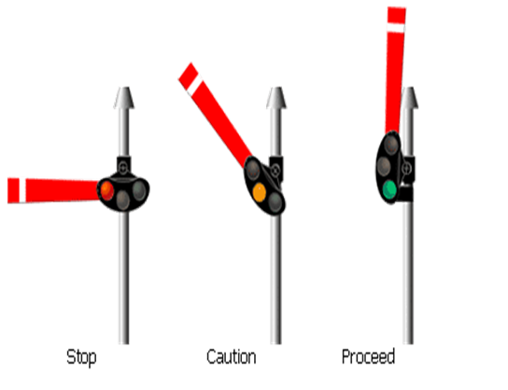

**Fig1.1: Train Pole Signals**

**1.1. GENERAL DESCRIPTION**

What we have to do is we have to attach a transmitter with signal pole which will start transmitting signals only when the red light is on. If there is green light no transmission. The engine has a receiver which catches these transmitted signals and takes desired actions.

Both the transmitter and receiver are of RF type with minimum range of 2 Km. so that train can get enough time to decrease its speed and stop before the signal pole with minimum swapping distance of 100-200 meters.

Here, we use RF transmitter and receiver modules but same idea can be easily implemented with IR transmitter and receiver but IR transmitter and receiver is used for short distance communication in range of meters and it is costly, while Radio Frequency transmitter and receiver is used for long distance communication in range of kilometers and we can make this project with minimum cost by using RF modules.

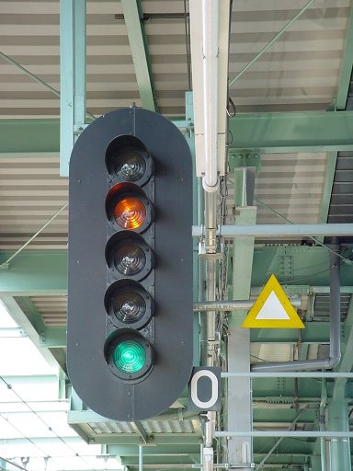

**Fig1.2: Signal Pole with Red and Green Light**

**1.2. DEMONSTRATION MODEL**

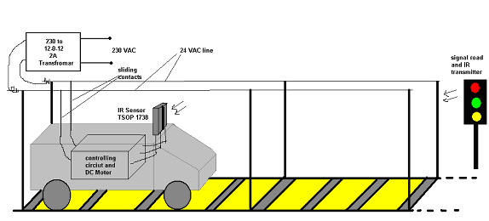

**Fig1.3: Demonstration Model**

The train engine runs on its own motor which is in built in train so that we can easily vary its speed by the use of microcontroller. Movable tapping are taken from this line and fed to the internal circuit of engine. These tapping slides as the train run on the track and give continuous supply to circuit. The RF receiver placed at the top of the engine senses the signals transmitted by RF transmitter attached to signal pole or we can use the transmitter circuit as a remote in our hand. Train track is straight and 20 ft long. Signal pole is placed at the end of the track and train starts from further end.

The project is divided into two parts:

1. Transmitter
2. Receiver

The transmitter is housed in signal pole and it is activated only when red light is ON.

The receiver is housed in engine which senses the IR signals and takes suitable action.

1. **APPLICATIONS**

This project is mostly useful for human life and decreasing the ratio of accidents due to the traffic signals. Some points are given below for decreasing the ratio of accidents due to:

* **FOG IN WINTER**

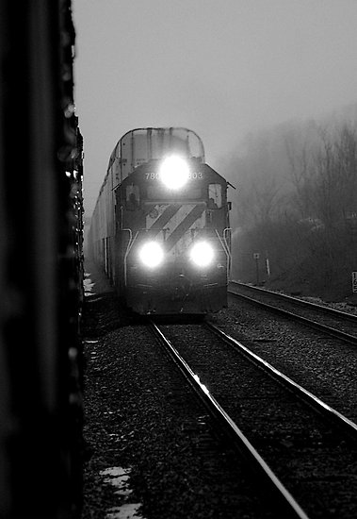

* **MISUNDERSTANDING BY DRIVER OF TRAINS**

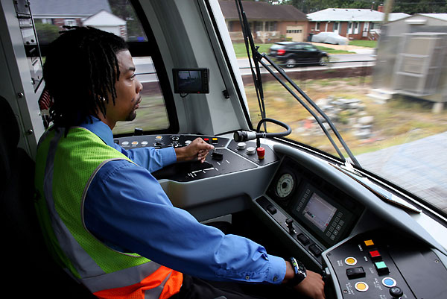

* **SUDDENLY CHANGING IN TRAFFIC LIGHTS**

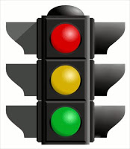

* **CAN BE USED FOR OTHER VEHICLES**



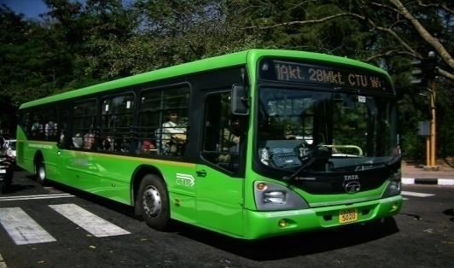

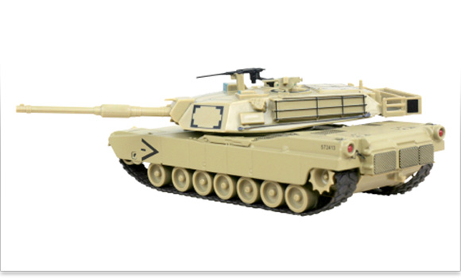

* **CONTROLLING SYSTEM**

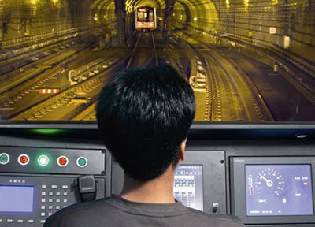

**Fig2: Applications of Self Controlled Locomotive**

**3. BLOCK DIAGRAM**

* 1. **TRANSMITTER SECTION**

**RF Transmitter**

**Encoder**

**Circuit**

**DETECTION & TRANSMISSION VIA UC AT89C51**

**RED, GREEN, YELLOW**

**SIGNALLING VIA PC**

**RED,GREEN,YELLOW**

**Fig3: Block Diagram of Transmitter Section**

1. **Signaling via PC:** This block is used to interface PC with microcontroller, and then with this we can control our locomotive via computer and with this we can find out the exact location of the train. We can transfer data from PC to receiver and we can easily control the train.

Here we use three LEDs i.e. red, green and yellow for station indication. So whenever first, second and third station comes the LEDs glow accordingly.

Several devices collect data from sensors and sends it to another unit, like a computer, for further processing. Data transfer/communication is generally done in two ways: parallel and serial. In the parallel mode, data transfer is fast and uses more number of lines. This mode is good for short range data transfer.

Serial communication on the other hand, uses only one or two data lines to transfer data and is generally used for long distance communication. In serial communication the data is sent as one bit at a time. This article describes the interfacing of [8051](http://www.engineersgarage.com/8051-microcontroller) microcontroller ([AT89C51](http://www.engineersgarage.com/at89c51-or-89c51-microcontroller)) with a computer via [serial port, RS232](http://www.engineersgarage.com/articles/what-is-rs232). Serial communication is commonly used in applications such as industrial automation systems, scientific analysis and certain consumer products.

1. **Detection and Transmission via microcontroller 8051:** In this section, microcontroller transmits signal to the encoder and detect the incoming data from PC. In this programming part is done which we want to do by the means of project and here three LEDs are connected to give the three type of signals and train is controlled accordingly with the given signal.
2. **Encoder Circuit:** This encoder circuit is used to encode the signal and pass it to the RF transmitter module. Here HT12E encoder is used.

An **encoder** is a device used to change a signal (such as a bit stream) or data into a code. The code may serve any of a number of purposes such as compressing information for transmission or storage, encrypting or adding redundancies to the input code, or translating from one code to another. In digital electronics this would mean that a decoder is a multiple-input, multiple-output logic circuit (2n-n)

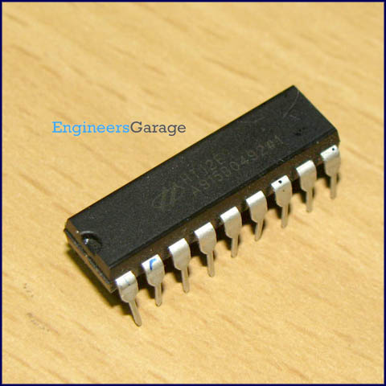

**Fig3.1: HT12E Encoder**

HT12E is an encoder integrated circuit of series of encoders. They are paired with series of decoders for use in remote control system applications. It is mainly used in interfacing RF and infrared circuits. The chosen pair of encoder/decoder should have same number of addresses and data format.

HT12E converts the parallel inputs into serial output. It encodes the 12 bit parallel data into serial for transmission through an RF transmitter. These 12 bits are divided into 8 address bits and 4 data bits.

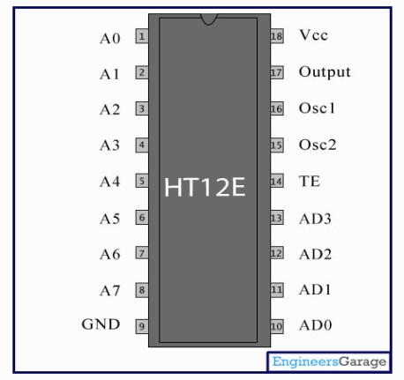

**Fig3.2: Encoder Circuit**

1. **RF Transmitter and Receiver Modules:**

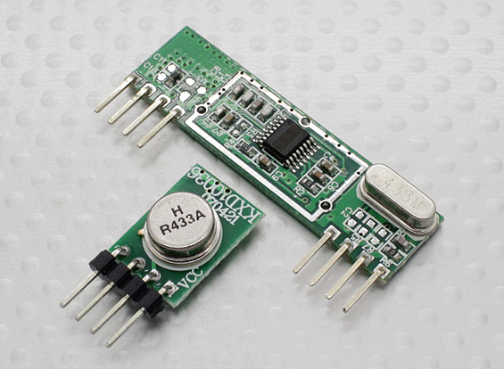

**Fig3.3: Radio Frequency Modules**

The RF module, as the name suggests, operates at Radio Frequency. The corresponding frequency range varies between 30 kHz & 300 GHz. In this RF system, the digital data is represented as variations in the amplitude of carrier wave. This kind of modulation is known as Amplitude Shift Keying (ASK).

Transmission through RF is better than IR (infrared) because of many reasons. Firstly, signals through RF can travel through larger distances making it suitable for long range applications. Also, while IR mostly operates in line-of sight mode, RF signals can travel even when there is an obstruction between transmitter & receiver. Next, RF transmission is more strong and reliable than IR transmission. RF communication uses a specific frequency unlike IR signals which are affected by other IR emitting sources.

This RF module comprises of an RF Transmitter and an RF Receiver. The transmitter/receiver (Tx/Rx) pair operates at a frequency of 434 MHz. An RF transmitter receives serial data and transmits it wirelessly through RF through its antenna connected at pin4. The transmission occurs at the rate of 1Kbps – 10Kbps.The transmitted data is received by an RF receiver operating at the same frequency as that of the transmitter.

The RF module is often used along with a pair of encoder/decoder. The encoder is used for encoding parallel data for transmission while reception is decoded by a decoder. HT12E-HT12D, HT640-HT648, etc. are some commonly used encoder/decoder pair ICs.

* **Pin Description**

**Transmitter Module**

|  |
| --- |
| Pin Number Function Name |
| 1 Ground (0V) GND |
| 2 Serial Data Input Pin DATA |
| 3 Supply Voltage (5V) VCC |
| 4 Antenna Output Pin ANT |

**Receiver Module**

|  |
| --- |
| Pin Number Function Name |
| 1 Ground (0V) GND |
| 2 Serial Data Output Pin DATA |
| 3 Linear Output Pin; Not Connected NC |
| 4 Supply Voltage (5V) VCC |
| 5 Supply Voltage (5V) VCC |
| 6 Ground (0V) GND |
| 7 Ground (0V) GND |
| 1. Antenna Input Pin ANT |

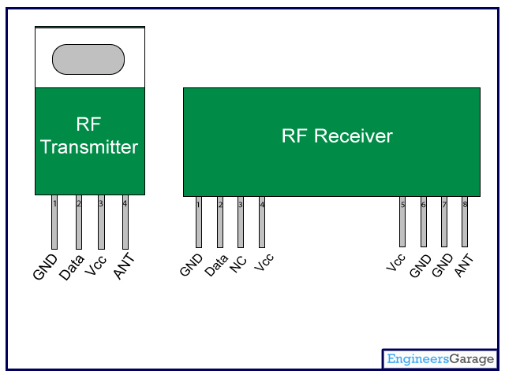

**Fig3.4: Pin Description**

**3.2 RECEIVER SECTION:**

**Gate motor**

**Controlling**

**Engine**

**Driving Ckt**

**UC**

**AT89C51**

**Decoder**

**Circuit**

**RF Receiver**

**IR SENSORS for gate**

**Fig4: Block Diagram of Receiver Section**

1. **Decoder Circuit:** This circuit is used to decode the signal and passes it to the microcontroller AT89C51.Here HT12D decoder is used.

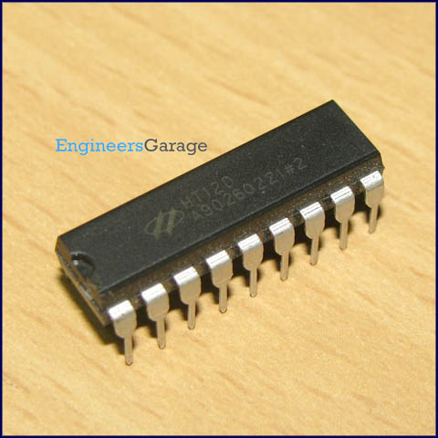

**Fig4.1: HT12D Decoder**

A **decoder** is a device which does the reverse of an encoder, undoing the encoding so that the original information can be retrieved. The same method used to encode is usually just reversed in order to decode. In digital electronics this would mean that a decoder is a multiple-input, multiple-output logic circuit (n-2n).

HT12D IC comes from HolTek Company. HT12D is a decoder integrated circuit that belongs to series of decoders. This series of decoders are mainly used for remote control system applications, like burglar alarm, car door controller, security system etc. It is mainly provided to interface between RF and infrared circuits. They are paired with series of encoders. The chosen pair of encoder/decoder should have same number of addresses and data format.

In simple terms, HT12D converts the serial input into parallel outputs. It decodes the serial addresses and data received by an RF receiver into parallel data and sends them to output data pins. The serial input data is compared with the local addresses three times continuously. The input data code is decoded when no error or unmatched codes are found. A valid transmission in indicated by a high signal at VT pin.

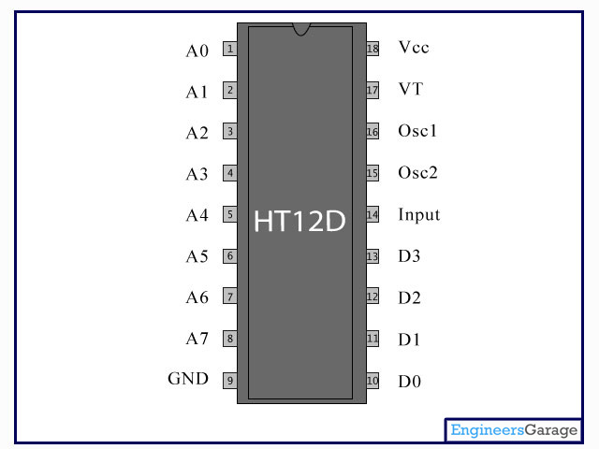

**Fig4.2: Decoder Circuit**

1. **IR Sensors for gate:** IR sensors are used here for automatically opening of the gate when it senses that train is coming. The gate opens automatically when it senses the signals from gate.

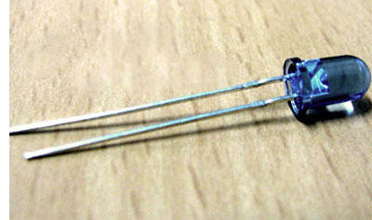

**Fig4.3: IR Sensor**

**4. CIRCUIT DIAGRAM**

**4.1 CONTROLLER CIRCUIT AT TRANSMITTER SECTION**

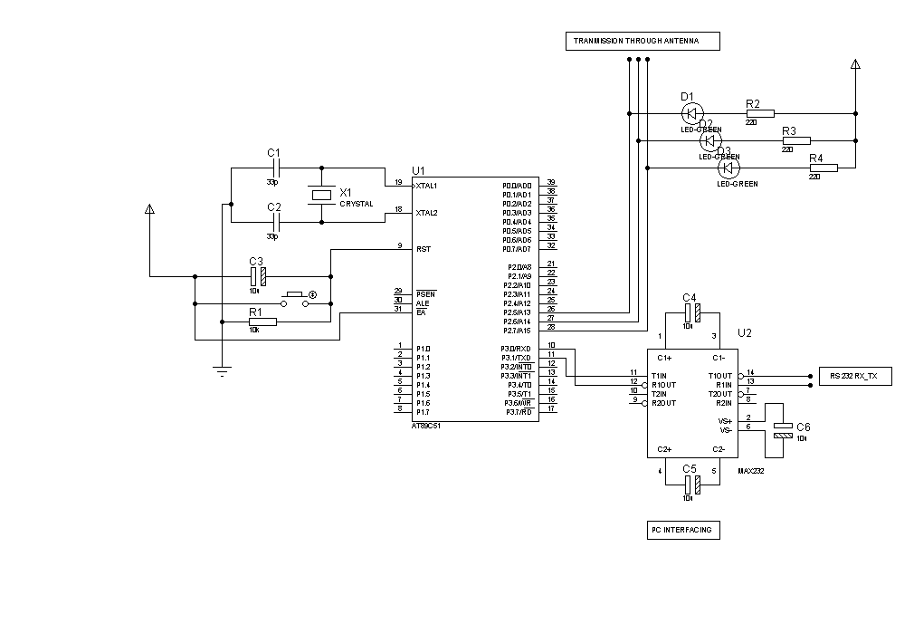

**Fig5: Circuit Diagram of Transmitter**

**4.2 CONTROLLER CIRCUIT AT RECEIVER SECTION**

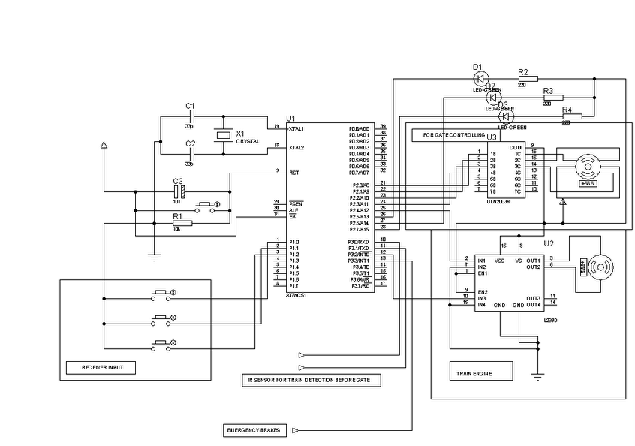

**Fig6: Circuit Diagram of Receiver**

**4.3 TRANSMITTER AND RECIEVER (ENCODER DECODER) CIRCUIT**

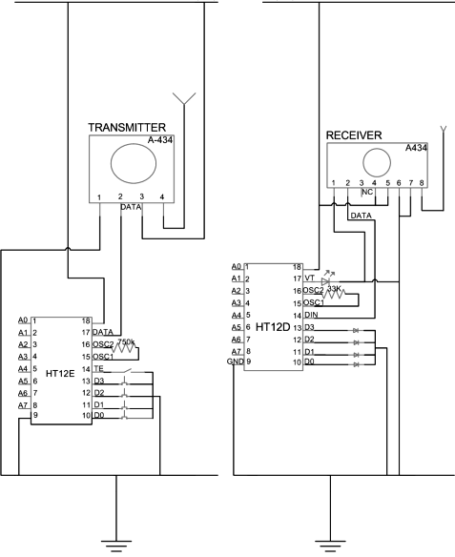

**Fig7: Encoder-Decoder Circuit Diagram**

**4.4 ADVANTAGES**

* The circuit is simple and cost is less.
* As it is microcontroller based the speed is automatically controlled.
* The circuit can be easily modified.
* Prevents accidents.
* Fault analysis is easy.
* Can be used for other vehicles.
* Efficient way for evaluation of bank.
* Quick response time.
* Fully Automatic system.
* Robust system.
* Low power requirement.
* Less time delays.
* Safety to the Peoples.
* Automatic Operation.
* Less expensive.

**4.5 SOFTWARE USED:**

* **Keil Software:**

The µVision IDE from Keil combines project management, make facilities, source code editing, program debugging, and complete simulation in one powerful environment. The µVision development platform is easy-to-use and helping you quickly create embedded programs that work. The µVision editor and debugger are integrated in a single application that provides a seamless embedded project development environment.

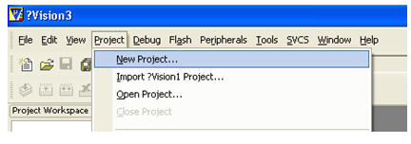

* **Top view Simulator:**



Top view Simulator gives an excellent simulation environment for MCS 51 Microcontroller.

A beginner can learn about 8051 based embedded solutions without any hardware. An experienced designer may find most of the required facilities built in the simulator that enables you to complete your next project without waiting for the target hardware.



**5. JOB COMPLETION**

**SPEED CONTROL OF THE TRAIN**

In this section we are controlling the speed of our train engine. For the demonstration purpose we will be providing three switches for each parameter so that we can simulate and show the result of our system effectively. These switches will be fixed to the transmitter circuit. The RF transmitter will be with us and the receiver circuit is housed in the train itself.

The RF transmitter continuously transmits the signal to the RF receiver. The RF receiver receives the signal obtained from the transmitter and will control the speed of the train accordingly.

When the first switch is pressed, then the train will run at its full speed means at 100% duty cycle.

And then, when the second switch is pressed then the train will run at half of its speed i.e. at 50% duty cycle. When the third switch is pressed then the train will stop moving.

When this project is implemented in the real time system then our transmitter circuit will be housed at the signal pole and the receiver circuit will be housed in the train as in the demonstration model. The train engine senses the light signal that is sent by the transmitter circuit from the signal pole and this signal is received by the receiver circuit at the train and the speed of the train is controlled.

When the light at the signal pole is green then the train runs at its full speed, when the light at the signal pole is yellow then the train will run at half of its speed and when the light at the signal pole is red then the train will get stopped.

**6. PROPOSED WORK**

* **RAILWAY GATE CONTROL**

In this section we are controlling the railway gate. When we will get the information at the railway gate section about the train that the train is coming, then the railway gate will get closed automatically without the help of any person. Here, the RF transmitter is fixed to the train and the RF receiver is housed at the railway gate control section.

The transmitter continuously transmits the data to the RF receiver. The receiver will get the information about the coming of the train when the train is at 100m distance from the railway gate control section. The RF receiver section, as soon as it receives the data from the transmitter, closes the railway gate by rotating the stepper motor fixed to the gate and opens it after a predetermined delay.

* **INFORMATION ABOUT THE STATION**

In this section we will get the information about the station of the train i.e. we will get to know that our train is on which station at that particular instant.

For this purpose we are introducing the LED with the name of the station. When the train will be at that particular station then the LED corresponding to that station will glow automatically and we will get to know that on which station our train is at that instant.

* **CONTROLLING OF THE TRAIN BY P.C**

In this section we are controlling the train with the help of the personal computer. As in today’s era each station has a personal computer at the railway station. Therefore, we can control the train with the help of that P.C.

In this we should connect PC direct with Microcontroller through interfacing. Here MAX232 and RS232 switch is used for interfacing which provide direct serial interfacing of PC with Microcontroller at the transmitter and with this we can easily control the locomotive through computer.

So we can also find the live status of the locomotive with this advancement and also avoids accidents by implementation of this idea.

**7. FUTURE SCOPE**

* The working of the project is explained and studied. There are many components to be used hence some of them are studied and some will be discussed in detail at the completion of this project.
* The working on hardware part and programming of microcontroller is going on and can be shown as working in the end of the project.
* The receiver part of the project can be modified by using LED station indication which will be shown in the end of this project.
* Moreover, we can control the train engine with the help of the PC from the station instead of the driver.
* Reduce transportation delay.
* Using RFID, automatically opening and closing of the gates can be possible.
* If the track breaks then SMS can be sent to the base station using GSM module so that the action can be taken immediately.

[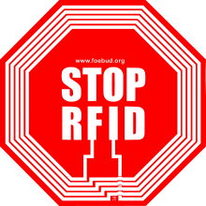](http://en.wikipedia.org/wiki/File:Stoprfid-logo.svg).  
**Fig8: Future Application through RFID**

**8. CONCLUSION**

* In this project which is based on RF technology wireless train engine is controlled from remote area within the range of 2 km. So, now before the driver observes the red signal the engine itself observes it and automatically starts decreasing speed and then stops.
* The driver can feel relax in driving because he doesn’t have to take care about red signal. Even if he forgets to take any action on red signal then also we can avoid accidents by the implementation of this idea.
* This project is to avoid the accidents which occur by signal problems and train problems.

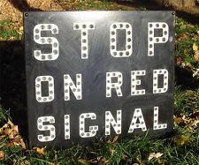

**9. LITERATURE SURVEY**

1. Martin. (2011) SSRN Avoid accidents and railway gate controlling. *IUP Journal* of *Electrical & Electronics Engineering*, Vol IV, No 4, pp. 36-47.

2. Kumar, Sanjeev, Gupta, Shweta and Sharma, Dibyayan Das. (July 19, 2012) *An Intelligent Train Engine Based on Auto-Signal Following Scheme Using IR Technology*.

3. B.P.Singh. (2005) *Advanced Microprocessor and Microcontroller*.

4. Mohammed Ali Mazidi. (2006) *Microcontroller and Embedded System*.

5. Muhammad Ali Mazidi. (2006) *The PIC16F7X Microcontroller and embedded systems*. 2nd Ed. Pearson Education.

6. Ajay Deshpandey. (2002) *PIC Microcontroller*.

7. Mike Predko. (2002) *Programming and customizing the PIC Microcontroller*. 3rd Ed. Tata McGraw-Hill.

8. P. Gupta. (2012) Driver less car. *Electronics for U*, Vol 2, No 12, pp. 20-25.

9. Simon Monk. (2013) LED Blinking. *Practical Electronics for Inventors*, Vol 3, No 9, pp. 12- 15.

10. http://[www.atmel.com](http://www.atmel.com) [accessed 27/09/2013]

11. http://[www.wikipedia.com](http://www.wikipedia.com) [accessed 27/09/2013]

12. http://[www.altavista.com](http://www.altavista.com) [accessed 27/09/2013]

13. <http://www.engineersgarage.com/electronic-circuits/wireless-rf-remote-control-circuit>.

14. <http://www.atmel.com\dyn|resources|prod> documents/doc0509.pdf.